# 1. INTRODUCTION

## **1.1 OVERVIEW**

The project deals with the idea of provisioning of a remote access to the lighting system of the client’s house, office or institute, and to provide various controls such as On/Off, Intensity, color.

**1.2 BRIEF DESCRIPTION**

The remote lighting system provide a user friendly GUI which lets the user to control the lighting system of his choice without being physically present at the site. User can do the tasks like turning the LEDs ON/OFF, controlling the intensity, and changing the colour of the LEDS.

The GUI is built on the website where the user can login into his account and after logging in he gets the control over his lighting system. The LEDs are represented in small circle and the controlling is through mouse click.

**1.3 PROBLEM DEFINATION**

To set up a website portal, this will provide remote access to clients lighting system and to provide tools to control them like ON/OFF, dimming, and RGB color.

**1.4 Applying Software Engineering Approach**

Agile software development (ASD) is a methodology for the creative process that anticipates the need for flexibility and applies a level of pragmatism into the delivery of the finished product. Agile software development focuses on keeping code simple, testing often, and delivering functional bits of the application as soon as they're ready. The goal of ASD is to build upon small client-approved parts as the project progresses, as opposed to delivering one large application at the end of the project.

Different Phases involved in Agile Development are as follows:

* Software Requirements: The elicitation, analysis, specification, and validation of requirements for application. Questionnaires were made and different people were involved. Their answers were surveyed and accordingly these were documented.
* Software Design: The process of defining the architecture, components, interfaces, and other characteristics of a system or component. It is also defined as the result of that process. Analyzed the collected document, and these were independently researched. UML diagrams were used to design the software environment. This gave an insight on the future software design and its feasibility.
* Software Construction: The detailed creation of working, meaningful software through a combination of coding, verification, unit testing, integration testing, and debugging. The code was modularized in smaller, more realizable chunks, and these were worked on independently, finally integrated. Some amount of parallel programming was also introduced.
* Software Testing: The dynamic verification of the behavior of a program on a finite set of test cases, suitably selected from the usually infinite executions domain, against the expected behavior. Individual components were tested independently to perform unit testing, finally integrated and integration testing was performed .Regression testing were also performed, the application was tested for various loads.
* Software Maintenance: The totality of activities required to provide cost-effective support to software. All the data structures were thoroughly optimized, and the code structure was optimized to its core. This gave reliability, and also improved the response time.
* Software Engineering Process: The definition, implementation, assessment, measurement, management, change, and improvement of the software life cycle process itself. Incremental model was used to develop the software in the long term. We see that there can be more improvements in the software design. There were changes made to the template, and these changes were incorporated in the code.

**1.5 Need for the Project**

In a daily environment, it is a tedious job to actually go to every switch of the lights and control them; it is easy for small lighting system but consider the lighting system of the industry or a big institute. It would be very easy if we have these controls on one place like a PC, or on the go. So keeping this in mind, we aim at providing the liberty to the client to just have an internet connection and a browser to control the respective lighting system.

Consider a huge institute or a huge company having many building and thousands of light switches. It takes lots of effort to manually switch them on/off. So, to overcome this drawback, we should be able to control the entire group of lights. When we give the command to the group, the command is then applied to the entire group of LEDs present in the group. This saves both the time and the manpower. We can also monitor the working of each and every light in the system and analyze the power consumption and other factors. Another tool that can be implemented is the automation system. In a company suppose there is a holiday on the particular day, so can set a command in the system that will turn the lights off in that period and this can be overridden to a manual control.

Currently, there are projects that have implemented this type of the system using the traditional remote control device. These types of projects have many limitations, the major limitation is the range of the device, the maximum range of many infrared devices is 10meters. The range is also hampered by any object that is directly present in between the remote control and the end device. This drawback is overcome in this project by using the wireless communication, which also works between the walls.

**2. LITERATURE SURVEY**

# 2.1 An Implementation of Remote Lighting Control System Based on Zigbee Technology and Soc Solution[1]

Based on the study of the characteristics of ZigBee technology[7] and the analysis of the structure of wireless sensor networks, here proposed a new reliable, flexible and inexpensive Remote Lighting Control System based on ZigBee technology and SoC (System-on- Chip) solution[2]. This paper emphasizes on the implementation of ZigBee protocol and data communication flow. The hardware and software design are presented. The experimental and application results have shown that ZigBee technology is suitable for wireless control in home lighting and proved that the new wireless sensor network has a more vast range of prospects in home automation and industrial control.

**2.2 ZigBee Technology**

ZigBee is a wireless network standard defined by ZigBee Alliance and based on the IEEE 802.15.4.[3] The standard focuses on low rate, low cost, low power consumption, robustness, reliability and self-healing. Solutions adopting the ZigBee standard will be embedded in consumer electronics, home and building automation, industrial controls, PC peripherals, medical sensor applications, toys and games. The ZigBee stack architecture, which is depicted in Figure 1, is based on the standard Open Systems Interconnection (OSI) seven-layer model[7] .The IEEE 802.15.4 standard defines the lower two layers: the physical (PHY) layer and the medium access control (MAC) sub-layer. The ZigBee Alliance builds on this foundation by providing the network (NWK) layer and the framework for the application layer, which includes the application support sub-layer (APS), the ZigBee device objects (ZDO) and the manufacturer defined application objects. Each layer performs a specific set of services for the layer above. Fig. 1 ZigBee stack architecture The ZigBee network layer (NWK) supports star, tree and mesh topologies. In a star topology, the network is controlled by one single device called the ZigBee coordinator. The ZigBee coordinator is responsible for initiating and maintaining the devices on the network, and all other devices, known as end devices, directly communicate with the ZigBee coordinator. In mesh and tree topologies, the ZigBee coordinator is responsible for starting the network and for choosing certain key network parameters but the network may be extended through the use of ZigBee routers. In tree networks, routers move data and control messages through the network using a hierarchical routing strategy. Mesh networks shall allow full peer-to-peer communication. A ZigBee network can be composed by FFD (Full Function Device) and RFD(Reduced Function Device)[7]. Only the FFD defines the full ZigBee functionality and can become a network coordinator, it has the function of routing and relay. The RFD has limited resources and does not allow some advanced function (e.g. routing).



Fig 2.1: ZigBee Stack Architecture[13]



Fig 2.2: Topology of ZigBee network[13]

**2.3 EXISTING SYSTEM**

The existing home automation techniques are based upon remote control devices working on infrared technology. The end devices are also equipped with an infrared receiver; the remote control has a transmitter which transmits the signal to the receiver on the end device. This is a cheap and low quality system.

**2.3.1 Disadvantages[3]**

* Limited range about 10 meters.
* Signals are obstructed by an opaque object between the transmitter and receiver.
* Size of the remote control device is fixed so limited end devices can be added.
* Very inefficient method in terms of time and output.

**2.4 PROPOSED SYSTEM**

Our plan is to make a system which will enable the user to control the total lighting system using the web. The system will make the user independent of not being physically present in the geographical location of the lights. The system will give the user controls like switching ON/OFF of the lights and setting the intensity of lights. The system can be used through any OS as it is a web based system and can be accessed through any web browser.

**2.4.1 Advantages**

* System provides an easy, efficient and an aesthetically pleasing platform for the user to control the lighting system.
* System frees the user from being present physically at the location.
* User can control group of lights at a single instance.
* System is free from the range constraint.
* No limitation of adding end devices.

**2.5 ZIGBEE TECHNICAL CHARACTERISTICS[3]**

ZigBee is a kind of proposal wireless communication technology, which is applied in short range, low transmission rate between the various electronic equipments. ZigBee as emerging wireless transmission technology standard has its unique technical characteristics:

**A. Low power consumption:**When ZigBee node is under working-mode circumstance, the transmission rate is low, the amount of data transmission is small, all these factors reduce the time of receiving and sending signals; and under the non-working-mode circumstance, ZigBee node is dormant. Both of two working modes determine the low consumption.

**B. Reliability:** ZigBee’s MAC layer adopts talk-when-ready collision avoidance mechanism. Under this mechanism, when the data transmission requirements appeared, node will send each packet immediately and wait for confirmation reply information comes from the recipient; if do not receive any reply message proves collision happened, and will transmit once again.

**C. High expansibility:** A ZigBee network can contain 255 ZigBee nodes, one is the master node and others are all slave nodes. If through network coordinator forms net, and network coordinator can also interconnected each other, the whole net can contain 65000 nodes. At last the whole number is very considerable.

**2.6 Comparing PHP, Python and Ruby based on several criterions:**

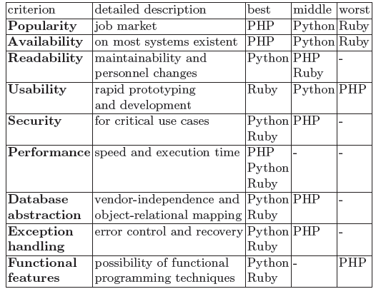

Table 2.1: Comparison between PHP, Ruby and Python on various criteria[9]

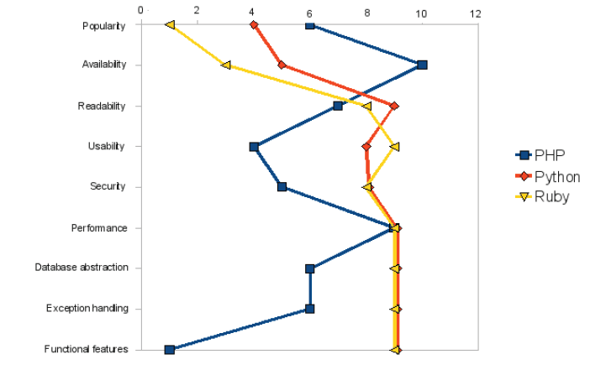

Fig 2.3: Relative comparison of the languages in terms of ratings from 0 (worst) to 10(best)[9]

**2.7 Using ZigBee to Build a Web-Based DCS System**

This paper presents the design and implementation of a web based Distributed Control System DCS built on wireless communication protocols IEEE 802.15.4[1], Zigbee and Digimesh. The development of decentralized (distributed) input-output Systems used for the process control, data acquisition and monitoring could be executed by dividing the overall system into many subsystems, each carries only the code necessary for a specific set of activities in contrast to a centralized control system that requires complex programming needed to govern the entire system. The monitoring and process control unit for each subsystem is geographically distributed in the controlled plant, each subsystem node is based on the wireless Xbee modules Series I or Series II, which are capable to be configured to work in a network under some different topologies like star, cluster tree and mesh. With these module implementations of the Zigbee Wireless Networks with geographic coverage increasing rang are possible. Xbee module is a low cost and powerful tool for implementation of distributed control systems. Because the basic standalone XBee radio does not allow access to any kind of logic , the incorporation of external microcontroller to each subsystem node will be necessary to allow some form of local logic that requires knowledge of the C-like language. i.e up till now Xbee Module by itself is not intelligent. The Application Software for operator interface will be networked over the Internet to accomplish remote monitoring and controlling over the plant Ethernet using Dot Net programming technology (ASP.Net and Visual C-sharp) and the interface will be displayed as a secured HTML page in a website[12]. The above idea will be verified via a representative example using the technologies presented in this paper.

**3. SOFTWARE REQUIREMENT SPECIFICATION**

# 3.1 INTRODUCTION

The project is sponsored by the company called Danson Lightings Pvt. Ltd; this company is a global company and has the headquarters in Hong Kong and various branches all across the globe, for example, Australia, China, Singapore, Canada. The company produces various types of lighting devices for its clients. The lighting devices include tube lights, LED lights, bulbs, lamps, flood lights. The project is mainly concerned with the LED lights, since they consume less power and are long lasting and durable in nature.

The company wants to launch the project as there official software. This will not only give the user a new experience but also help the company make more revenue. The basic property of a LED light is that it can be turned on or off, we can also control the intensity of the LED through the PWM method and also change the LEDs color by passing the value of the color based on the value of the RGB field. There are many more properties of the LED light but we are going to realize the three characteristics discussed above. The on/off property of a LED is default property without it the LED cannot be in the system. The next properties intensity and RGB are secondary properties and some LEDs carry this property and some may not. The user will be able to control these LEDs through the website.

## **3.1.1 PROJECT SCOPE**

* Build a web portal where the user can login into his account to control the lights.
* Provide the basic controlling options like ON/OFF, dimming and changing color.
* The system will be working on a website online hence it won’t have any compatibility issues.

## **3.1.2 DESIGN AND IMPLEMENTATION CONSTRAINTS**

* The host device will require a 24/7 internet connection to control the lighting system from the website.
* The setup of the system at the clients place will always require professionals.
* The system is being developed for lights so it may not work for other kinds of devices.

## **3.1.3 ASSUMPTIONS AND DEPENDENCIES**

* + - The system assumes that the end device that is visible on the website is physically present on the clients system.
    - The system assumes that the users know about the functionality of the website and the task of each page.
    - The execution of the command given by the user is dependent on the availability of the internet and the end device.
  1. **SYSTEM FEATURES :**
     1. **INTERACTIVE GUI :**

System provide a very user friendly GUI to operate on the lights.

* + 1. **SECURTIY:**

System provides high level security to the users account, so that any unauthorized person cannot access the account.

* + 1. **NETWORKING :**

System allows communication between server and client.

* 1. **EXTERNAL INTERFACE REQUIREMENTS:**

**3.3.1 HARDWARE INTERFACES**

* Communication: ZigBee modules, modem/router.

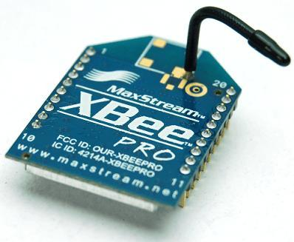

Fig 3.1 Zigbee Module[15]

* Microcontroller: Arduino with an Ethernet shield.

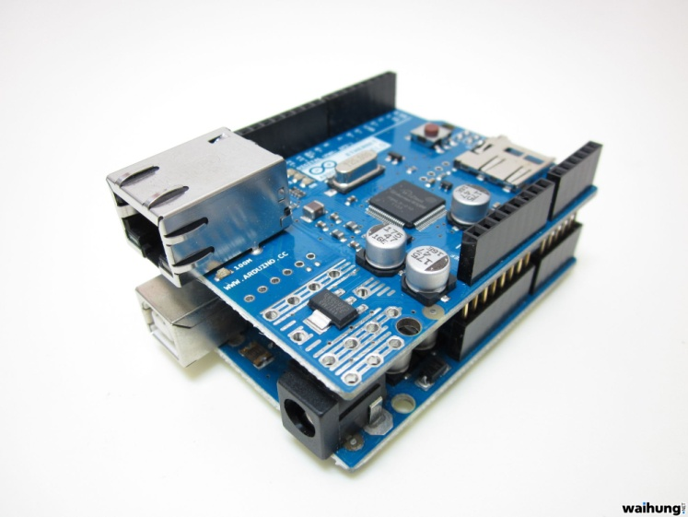

Fig 3.2: Ardunio with an Ethernet Shield[15]

* Others: LEDs, wires, etc.

### 3.3.2 SOFTWARE INTERFACES

* Operating System: System is platform independent
* Browser: Browsers that supports HTML5. ( Recommended: latest version of firefox)

## **3.4 NON-FUNCTIONAL RQUIREMENTS:**

## **3.4.1 PERFORMANCE REQUIREMENTS**

1. Robustness

The ability of system to resist change without adapting its initial stable configuration. Our system can have efficient exception handling ability and in our system we may do validations in all code areas.

2. Efficiency

The degree to which the software makes optimal use of system resources as indicated by sub-attributes like time behavior, resource behavior.

**3. Correctness**

The extent to which software satisfies its specification and fulfils customer’s mission objectives is called correctness of system.

4. Maintainability

The effort required to locate and fix an error in the system is called maintainability. In our system, for example while changing the state of the LED an error occurs we will display the message on the screen and the steps to troubleshoot the error.

5. Reliability

The amount of time the software is available for use is called as reliability. Our system will available for the user till he/she is logged in to the system.

6. Performance

It is necessary to check run time performance of the software within the context of an integrated system. Performance problems can result from lack of server side resources, inappropriate network and inappropriate capabilities. In our system client and server are connected using wireless communication. So, the performance is dependent on the transfer rate and correctness of the data.

7. Usability

Usability is the ease of use and learn ability of human made object and it can be software application. In our system we are providing the user manual with the help of which a new user can also operate our system easily.

**8. Reusability**

It is the source of code that can be used again to add new functionalities with slight or no modifications. Reusable modules and classes reduce implementation time.

**9. Ease of Installation**

Our system is using the available and the open source software, so installation and configuration is much easier.

**10. Reusability**

Our system is using all the open source software, so installation and configuration is much easier. The hardware part of the system will be taken care of by the company so the user need not worry about that.

### 3.4.2 SAFETY REQUIREMENTS

Due to the nature of the software under development, the safety of the data involved is a prominent issue. As the data under processing is often sensitive or important, data safety is of paramount importance. Data safety can be achieved in a Maintaining a secondary copy of the data under process i.e. Backups.

It should be taken care that the system does not crash and the hardware system should be kept at a secured and safe place so that it is not disturbed physically that might cause it damage.

**3.4.3 SOFTWARE QUALITY ATTRIBUTES**

|  |  |  |  |  |  |
| --- | --- | --- | --- | --- | --- |
| Attributes | Availability | Reliability | Usability | Maintainability | Testability |
| Availability |  | > | > | > | > |
| Reliability |  |  | > | > | > |
| Usability |  |  |  | < | > |
| Maintainability |  |  |  |  | > |

Table 3.1: Software Quality Attributes

**3.5 ANALYSIS MODELS**

**3.5.1 DATA FLOW DIAGRAM**

**LEVEL 0**

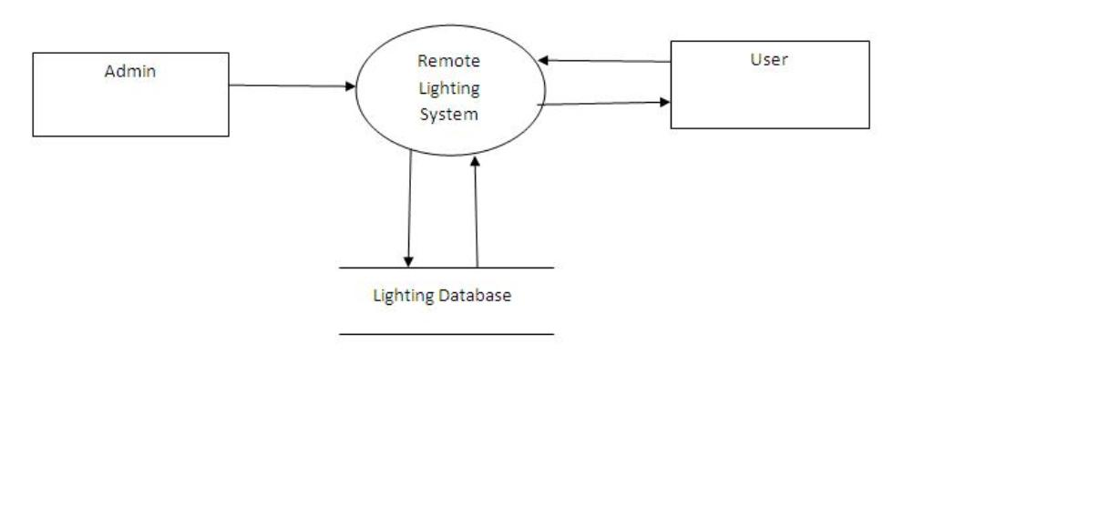

Fig 3.3: Data flow diagram level 0

**LEVEL 1**

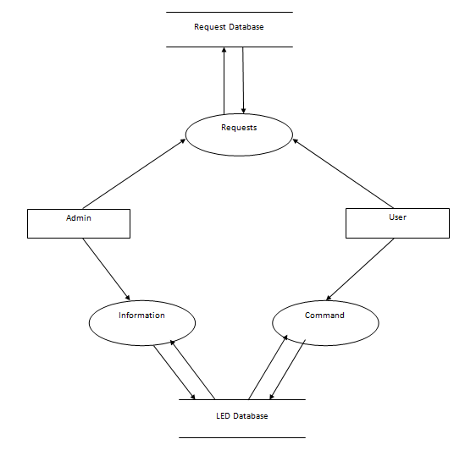

Fig 3.4: Data flow diagram level 1

**LEVEL 2**

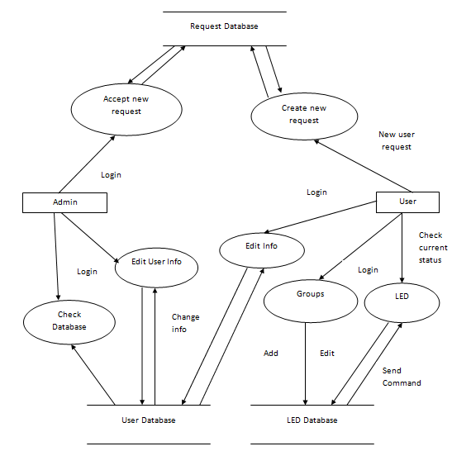

Fig 3.5: Data flow diagram level 2

**3.5.2 CLASS DIAGRAM**

In software engineering, a class diagram in the Unified Modeling Language (UML)[13] is a type of static structure diagram that describes the structure of a system by showing the system's classes, their attributes, operations (or methods), and the relationships among the classes. The class diagram is the main building block of object oriented modeling. It is used both for general conceptual modeling of the system of the application, and for detailed modeling translating the models into programming code. Class diagrams can also be used for data modeling. The classes in a class diagram represent both the main objects, interactions in the application and the classes to be programmed.

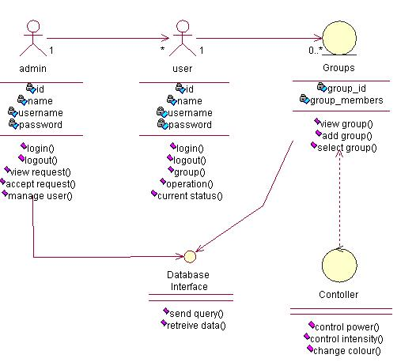

Fig 3.6: Class Diagram

**3.5.3 STATE TRANSITION DIAGRAM**

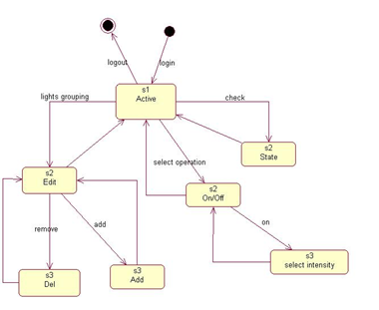

Fig 3.7: State diagram

**3.6 SYSTEM IMPLEMENTATION PLAN**

This system works through 3 stages Web Interface, server and client.

**Web Interface:**

Web Interface is the module with which user has to interact directly. This is the GUI of the system. The functionalities provided are:

* Controlling the LEDs i.e. ON/OFF, intensity and RGB colour.
* Adding new LEDs.
* Deleting existing LEDs.
* Changing Position of LEDs.
* Creating and Editing groups of LEDs.

**Communication between Website and server:**

User sends request to the server for particular operation. Server listens to the request and accepts the request and creates the socket between the server and the client remote pc and forwards the command.

**Communication between Client and hardware:**

At the client’s place, a PC is always connected to the internet and a microcontroller is connected to this PC. The server sends the command through the socket to this PC which further serially sends the command to the microcontroller which is attached to the LED circuit.

# 4. SYSTEM DESIGN

**4.1 SYSTEM ARCHITECTURE**

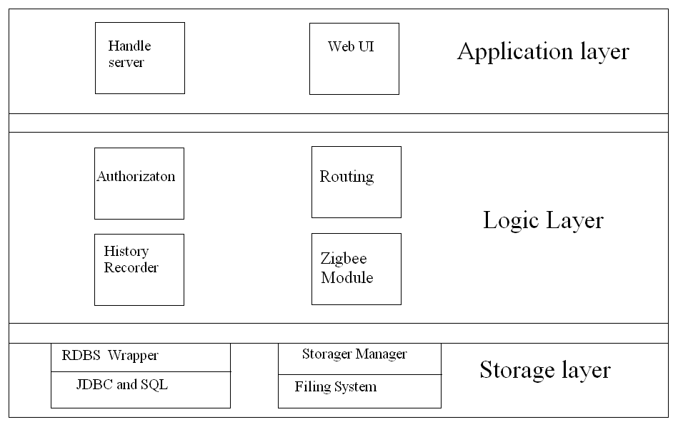

Fig 4.1: Architecture diagram

The flow of control in the architecture is as follows:

1. The user sends a request for a particular LED to the web server.
2. The web server forwards request to client side pc.
3. The client side PC serially forwards the command to the microcontroller which controls the LED.

The web, application and database servers are independent pieces of software which can be installed on the same computer or on different computers. This gives systems administrators a lot of flexibility when they deploy these systems. Web Interface for Remote Lighting System is built around a three-tier architecture model, shown in Figure. At the base of an application is the database tier, consisting of the database system that manages the database. Built on top of the database tier is the complex middle tier, which contains most of the application logic and communicates data between the other tiers. On top is the client tier, interactive GUI that interacts with the application. When we use the term "the Web," we mean three major, distinct standards and the tools based on these standards: the Hypertext Markup Language (HTML), the Hypertext Transfer Protocol (HTTP), and the TCP/IP networking protocol suite[3]. HTML works well for structuring and presenting information using a web browser application. TCP/IP is an effective networking protocol that transfers data between applications over the Internet and has little impact on web database application developers. The problem in building web database applications is interfacing traditional database applications to the Web using HTTP[17]. This is where the complex application logic is needed. When this architecture is implemented the benefits will become apparent as more code can be shared instead of being duplicated. Several components in the presentation layer can share the same component in the business layer, and all components in the business layer share the same component in the data access layer. Note also that a presentation layer component can access more than one business layer component, and a business layer component can access other business layer components. The big advantage of a 3-tier system is that it is possible to change the contents of any one of the tiers/layers without having to make corresponding changes in any of the others. For example: A change from one DBMS to another would only require a change to the component in the data access layer.A change in the Use Interface, for example from desktop to the web, would only require changes to the components in the presentation layer.

* 1. **UML DIAGRAMS**

**4.2.1 USE CASE DIAGRAM**

A use case diagram in the Unified Modeling Language (UML)[13] is a type of behavioral diagram defined by and created from a Use-Case design. Its purpose is to present a graphical overview of the functionality provided by a system in terms of actors, their goals, and any dependencies between those use cases.

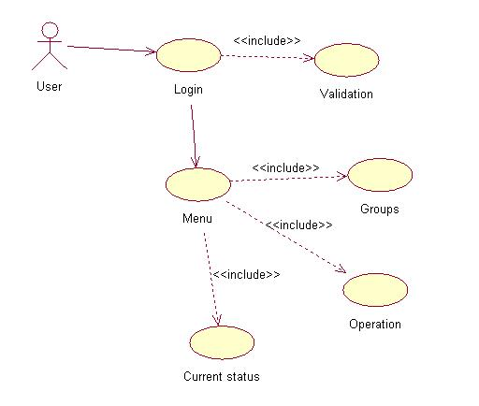

Fig 4.2: Use case for using basic functionality

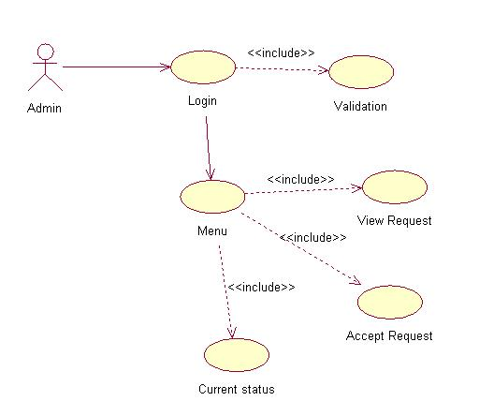

Fig 4.3: use case for admin operations

**4.2.2 ACTIVITY DIAGRAM**

Activity diagrams are graphical representations of workflows of stepwise activities and actions with support for choice, iteration and concurrency. In the Unified Modeling Language, activity diagrams can be used to describe the business and operational step-by-step workflows of components in a system. An Activity Diagram shows overall flow of the program.

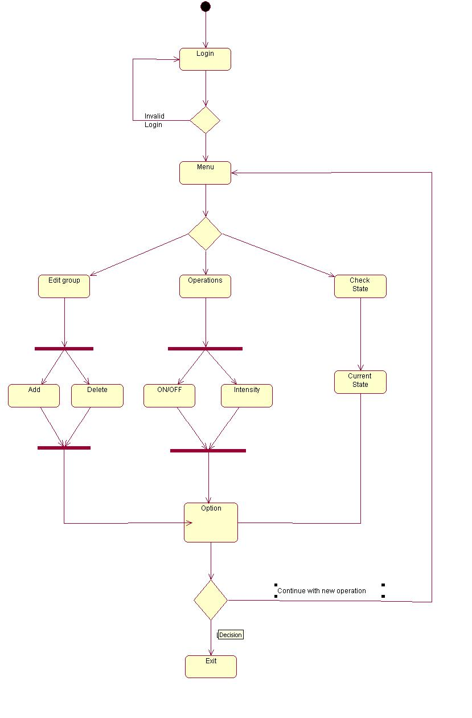

Fig 4.4: Activity diagram for user activities

**5. TECHNICAL SPECIFICATION**

**5.1 TECHNOLOGY DETAILS USED IN THE PROJECT**

* Operating System: Project is platform independent.
* External Software: Python 2.7.x, Django 1.5, MySQL 5.3, Sublime Text Editor.

**Python:**

**FEATURES OF PYTHON[9]:**

* **Simple:** Python is a simple and minimalistic language. Reading a good Python program feels almost like reading English, although very strict English! This pseudo-code nature of Python is one of its greatest strengths. It allows you to concentrate on the solution to the problem rather than the language itself.
* **Easy to Learn:** As you will see, Python is extremely easy to get started with. Python has an extraordinarily simple syntax, as already mentioned.
* **High-level Language:** When you write programs in Python, you never need to bother about the low-level details such as managing the memory used by your program, etc.
* **Embeddable:** You can embed Python within your C/C++ programs to give 'scripting' capabilities for your program's users.
* **Extensible:** If you need a critical piece of code to run very fast or want to have some piece of algorithm not to be open, you can code that part of your program in C or C++ and then use them from your Python program.
* **Object Oriented:** Python supports procedure-oriented programming as well as object-oriented programming. Python has a very powerful but simplistic way of doing OOP, especially when compared to big languages like C++ or Java.
* **Free and Open Source**: Python is an example of a FLOSS (Free/LibrÃ© and Open Source Software). FLOSS is based on the concept of a community which shares knowledge. This is one of the reasons why Python is so good - it has been created and is constantly improved by a community who just want to see a better Python.

**DJANGO WEB FRAMEWORK[10]:**

Django is a high-level Python Web framework that encourages rapid development and clean, pragmatic design.

Developed by a fast-moving online-news operation, Django was designed to handle two challenges: the intensive deadlines of a newsroom and the stringent requirements of the experienced Web developers who wrote it. It lets you build high-performing, elegant Web applications quickly.

* **Object-relational mapper:** Define your data models entirely in Python. You get a rich, dynamic database-access API for free — but you can still write SQL if needed.
* **Automatic admin interface:** Save yourself the tedious work of creating interfaces for people to add and update content. Django does that automatically, and it's production-ready.
* **Elegant URL design:** Design pretty, cruft-free URLs with no framework-specific limitations. Be as flexible as you like.
* **Template system:** Use Django's powerful, extensible and designer-friendly template language to separate design, content and Python code.
* **Cache system:** Hook into memcached or other cache frameworks for super performance — caching is as granular as you need.
* **Internationalization:** Django has full support for multi-language applications, letting you specify translation strings and providing hooks for language-specific functionality.

**5.1.1 ADVANTAGES**

* **It was written in Python** *–* many programmers agree that Python is one of the simplest programming languages that existed, yet interface in the most complex manner to a computer. With its syntax that is easily understandable, anyone can easily start himself to coding and eventually transition to Django[10]. It also carries with it the power that backs Python up, a wide host and array of libraries and third-party packages that can be easily integrated into your Django project to supplement its features.
* **Structured and organized development** *–* Django’s coding scheme revolves around building the website in phases. First the database is set up using abstract representations in the code called *models*. The features are laid out and coded individually through its *views*. The front-end displays and designs are designed through *templates*, and then finally woven together as one through URL maps and delicate code snippets that transition from one aspect to another. This way, individual developers can develop different chunks of the site and integrate them at the end of the day rather than having the development stagger because of missing or delayed developments from certain parts of the site.
* **Easy translation of syntax** *–* with Django, developers no longer need to worry about mastering the hardcore language of SQL or know a great deal of HTTP or XML syntax. Django provides supplemental codebases that can translate a database query for even the most novice database programmer and brings easy integration of the website in progress to an actual webpage that works as intended. Even front-end codes such as Javascript and AJAX can be integrated easily into the template pages just like any normal webpage[17].
* **It adheres strongly to the DRY principle** *–* the DRY principle, also known as the “Don’t Repeat Yourself” principle, is a known coding standard where developers must learn to become better object-oriented programmers. Many programmers make the simple mistake of repeating themselves in their codes, recoding features that they have already done in previous functions instead of just wrapping up the codebases in one function and just calling it between features. Django already has this in place and has many essential pieces of code for a developer built on its libraries.

**5.1.2 DISADVANTAGES**

* Django is too monolithic, and so…
* it encourages big, tightly-coupled apps.
* Everything depends on the Django ORM, whether it’s front-end stuff like sessions or back-end stuff like data persistence.
* Broad knowledge of the system is required.
* All components get deployed together.

## **REFERENCES TO TECHNOLOGY**

1. <https://www.djangoproject.com/>
2. <https://www.python.org/>

**6. SCHEDULE AND TEAM STRUCTURE**

**6.1 SCHEDULE**

|  |  |  |  |
| --- | --- | --- | --- |
| **Sr. No.** | **Task** | **Start Date** | **End Date** |
| 1 | Inception of project idea | 2/7/13 | 4/07/13 |
| 2 | Project Kickoff | 5/07/13 | 10/07/13 |
| 3 | Initial Domain Research | 11/07/13 | 12/07/13 |
| 4 | Inception of Literature Survey | 13/07/13 | 24/07/13 |
| 5 | Finalization of the Scope | 25/07/13 | 26/07/13 |
| 6 | Presentation of FTR1 | 29/07/13 | 29/07/13 |
| 7 | Survey for review papers | 06/08/13 | 15/08/13 |
| 8 | Drafting and submission of review papers | 16/08/13 | 21/08/13 |
| 9 | Preparation of UML diagrams | 22/08/13 | 23/08/13 |
| 10 | Preparation of SRS in IEEE | 23/08/13 | 24/08/13 |
| 11 | Finalization of Mathematical  Modeling | 24/08/13 | 29/08/13 |
| 12 | Presentation of FTR2 | 30/08/13 | 30/08/13 |
| 13 | Finalization of features | 4/09/13 | 14/09/13 |
| 14 | Deciding algorithms for features | 15/09/13 | 27/09/13 |
| 15 | Drafting and submitting of features | 28/09/13 | 07/10/13 |
| 16 | Presentation of FTR3 | 10/10/13 | 10/10/13 |
| 17 | Converting modules to code | 2/01/14 | 22/02/14 |
| 18 | Presentation of FTR4 | 06/01/14 | 06/01/14 |
| 19 | Presentation of FTR5 | 25/02/14 | 25/02/14 |
| 20 | Design of GUI | 28/02/14 | 06/03/14 |
| 21 | Finalization and implementation | 08/03/14 | 18/03/14 |
| 22 | Final project report | 19/03/14 | 26/03/14 |
| 23 | Presentation of FTR6 | 29/03/14 | 29/03/14 |
| 24 | Testing of project modules | 30/03/14 | 5/04/14 |

Table 6.1: Project Schedule

**6.2 TEAM STRUCTURE**

|  |  |
| --- | --- |
| **NAMES** | **ROLL NO** |
| Alok Karnik | B80394323 |
| Ketan Khandagale | B80394325 |
| Pratik Jambhulkar | B80394265 |

Table 6.2: Team Structure

**7. SOFTWARE IMPLEMENTATION**

**7.1 Introduction:**

Recently, along with the development of computer, automation and communication, the everyday life of people has changed a lot. People now pay more and more attention to the safety, health and comfort of the living environment. As there are so many kinds of lighting products, how to effectively make them become an integer and solve the inconvenience caused by distributed control and provide people with better living environment, the answer is Smart Home Lighting System SHLS). In the SHLS, it is a trend to apply wireless network technology to home automation network. Not only that wireless network can provide flexibility and reduce the cost of cabling, but also it accords with the feature of home network. In these days, people have explored so many kinds of wireless technology, ZigBee technology is one of them. ZigBee is a bi-direction wireless communication standard, it focuses on low power consumption and low cost and it fits for e case of wireless automatic control and measurement.

**7.2 Important Modules and Algorithms:**

Modules used to implement this project are:

* 1. Drawing shapes on canvas.
  2. Basic LED functionalities.

**7.2.1 Algorithm to draw circles on canvas**

This algorithm is based on the parametric form of the circle equation. For more see parametric equation of a circle.[13]

Recall that this looks like

x = h + rcosθ

y = k + rsinθ

where r is the radius of the circle, and h,k are the coordinates of the center.

What these equation do is generate the x,y coordinates of a point on the circle given an angle θ (theta). The algorithm starts with theta at zero, and then loops adding an increment to theta each time round the loop. It draws straight line segments between these successive points on the circle. The circle is thus drawn as a series of straight lines. If the increment is small enough, the result looks like a circle to the eye, even though in strict mathematical terms are is not.

**Algorithm**

Below is the algorithm in pseudo code showing the basic idea.

theta = 0; // angle that will be increased each loop

h = 12 // x coordinate of circle center

k = 10 // y coordinate of circle center

step = 15; // amount to add to theta each time (degrees)

repeat until theta >= 360;

{ x = h + r*cos(theta)

y = k + r*sin(theta)

draw a line to x,y

add step to theta

}

The decision about how big to make the step size is a tradeoff. If it is very small, many lines will be drawn for a smooth circle, but there will be more computer time used to do it. If it is too large the circle will not be smooth and be visually ugly.

**Example**

Below is the algorithm written in JavaScript using the HTML5 canvas element to draw into.

var ctx = canvas.getContext("2d");

var step = 2*Math.PI/20; // see note 1

var h = 150;

var k = 150;

var r = 50;

ctx.beginPath(); //tell canvas to start a set of lines

for(var theta=0; theta < 2*Math.PI; theta+=step)

{ var x = h + r*Math.cos(theta);

var y = k - r*Math.sin(theta); //note 2.

ctx.lineTo(x,y);

}

ctx.closePath(); //close the end to the start point

ctx.stroke(); //actually draw the accumulated lines

Like most graphics systems, the canvas element differs from the usual mathematical coordinate plane:

1. The origin is in the top left corner. The code above compensates by assuming that h, and k are actually relative to the top left.
2. The y axis is inverted. Positive y is down the screen, not up. To correct for this, the k variable (the y coordinate of the center) must be positive to place the center some way down the screen. Also the y calculation has to subtract the sin(x) term instead of add.   
   Marked in the code as Note 1.

Note 2. The step size is set to an exact division of 2π to avoid gaps or over-runs in the circle. This code divides the circle into exactly 20 segments. Note too that as in most computer languages, the trig functions operate in radians, not degrees. 360° = 2π radians.

**Clipping**

Since we have a separation between the models and the image created from those models, there can be parts of the model that do not appear in the current view when they are rendered.Pixels outside the clip rectangle are clipped, and are not displayed. can clip analytically - knowing where the clip rectangle is clipping can be done before scan-line converting a graphics primitive (point, line, polygon) by altering the graphics primitive so the new version lies entirely within the clip rectangle can clip by brute force (scissoring) - scan convert the entire primitive but only display those pixels within the clip rectangle by checking each pixel to see if it is visible[13].

* clipping a point against a rectangle -> nothing or single point
* clipping a line against a rectangle -> nothing or single line segment
* clipping a rectangle against a rectangle -> nothing or single rectangle ( Assuming the rectangle is aligned. Otherwise treat as convex polygon. )
* clipping a convex polygon against a rectangle -> nothing or single single convex polygon
* clipping a concave polygon against a rectangle -> nothing or 1 or more concave polygons

as with scan conversion, this must be done as quickly as possible as it is a very common operation.

**Point Clipping**

Let point (X,Y) be on canvas clipping rectangle with corners (Xmin,Ymin) (Xmax,Ymax)

point is within the clip rectangle if:

Xmin <= X<= Xmax  
Ymin <= Y<= Ymax

**7.2.2 Algorithm for Basic LED functionalities:**

To change the state of the LEDs in the system, the changes on the canvas are taken in set of variables and then passed onto the view in Django. The view then performs the corresponding task and makes the changes in the database and the database gets updated.

The steps to update the database are:

Step 1: Pass the values of the variables to the view through “post” method.

Step 2: Get those values from the variables in the view in another variables.

Step 3: Get the user name from the session variable.

Step 4: Connect to the user database from the username got from the session variable.

Step 5: Based on the operation perform the particular task and update the database.

Step 6: After successfully updating the database, save the database.

A sample view for on/off, intensity and RGB functionality:

*def update(request):*

*name = status = ""*

*username = ""*

*username = request.session['user']*

*name = request.POST.get('FirstName')*

*status = request.POST.get('ledstatus')*

*intensity = request.POST.get('intensity')*

*r = request.POST.get('R')*

*g = request.POST.get('G')*

*b = request.POST.get('B')*

*a = leds.objects.filter(username=username)*

*for i in a:*

*if i.name == name:*

*i.status = status*

*i.intesity = intensity*

*i.temp2 = 1*

*i.r = r*

*i.g = g*

*i.b = b*

*i.save()*

*pending_record = pendingwork.objects.get(username = username)*

*pending_record.pending = 1*

*pending_record.save()*

*return HttpResponseRedirect('/user_home/')*

After saving the database, the server sends the changed value to the end device if the device is connected to the server. The server sends the data through the internet using socket programming. There are two sockets present in this process, one at the server side and other on the client side. The communication takes place both ways i.e. bi directional communication. In the logic, while updating the database, pending variable is changed of the particular LED. Then the script continuously checks only the pending column of the database so that it saves time and works efficiently. When the script sees a pending operation it immediately sends the particular values to the client end device.

Sample code for sending the data to the end deive:

*def handler(clientsocket,addr,username):*

*while 1:*

*pendingflag = check(username)*

*if pendingflag == 0:*

*time.sleep(1)*

*if pendingflag == 1:*

*user_record = leds.objects.filter(username = username )*

*for i in user_record:*

*if i.temp2 == 1:*

*led_intensity = i.intesity*

*led_status = i.status*

*clientsocket.sendall(led_status, led_intensity)*

*i.temp2 = 0*

*i.save()*

*pending_record = pendingwork.objects.get(username = username)*

*pending_record.pending = 0*

*pending_record.save()*

**Category in which the algorithm falls (P, NP, NP-Complete, NP-Hard):**

The complexity class of decision problems that is intrinsically harder than those that can be solved by a non-Deterministic Turing Machine in polynomial time. When a decision version of a combinatorial optimization problem is proved to belong to the class of *NP-*complete problems, then the optimization version is NP-hard.

A generally-accepted minimum requirement for an algorithm to be considered ‘efficient’ is that its running time is polynomial: O(n^c) for some constant c, where n is the size of the input. There are several so-called NP-hard problems, which most people believe cannot be solved in polynomial time, even though nobody can prove a super-polynomial lower bound.

Turning LEDs off and on are a good example of a problem that we cannot guarantee that it can be solved in polynomial time; therefore, we can say it is **NP-Hard**.

**7.3 BUSINESS LOGIC AND ARCHITECTURE**

Business logic or domain logic is the part of the program that encodes the real-world business rules that determine how data can be created, displayed, stored, and changed. It is contrasted with the remainder of the software which might be concerned with lower-level details of managing a database or displaying the user interface, system infrastructure, or generally connecting various parts of the program. This software project has been implemented by coding the project module-wise and then integrating it together. The modules have been divided according to their function and according to their structures. Without modules, it would have been practically impossible to accomplish the project. Hence we can state that the business logic used in this case is the divide and conquer strategy. A complex task of controlling the lights has been divided into small tasks of finding out individual items.

**8 SOFTWARE TESTING**

**8.1 INTRODUCTION**

Testing can never completely identify all the defects within software. Instead, it furnishes a criticism or comparison that compares the state and behaviour of the product against oracles—principles or mechanisms by which someone might recognize a problem. These oracles may include (but are not limited to) specifications, contracts, comparable products, past versions of the same product, inferences about intended or expected purpose, user or customer expectations, relevant standards, applicable laws, or other criteria[12].

A primary purpose of testing is to detect software failures so that defects may be discovered and corrected. Testing cannot establish that a product functions properly under all conditions but can only establish that it does not function properly under specific conditions. The scope of software testing often includes examination of code as well as execution of that code in various environments and conditions as well as examining the aspects of code: does it do what it is supposed to do and do what it needs to do. In the current culture of software development, a testing organization may be separate from the development team. There are various roles for testing team members. Information derived from software testing may be used to correct the process by which software is developed. Software testing is a process used to identify the correctness, completeness and of a developed computer software. Software testing can also provide an objective, independent view of the software to allow the business to appreciate and understand the risks of software implementation. Test techniques include, but are not limited to the process of executing a program or application with the intent of finding software bugs (errors or other defects).

Software testing can be stated as the process of validating and verifying that a computer program/application/product:

* meets the requirements that guided its design and development,
* works as expected,
* can be implemented with the same characteristics,
* and satisfies the needs of stakeholders.

Software testing, depending on the testing method employed, can be implemented at any time in the software development process.

**Verification and Validation:**

Verification and Validation (V&V) is the process of checking that a software system meets specifications and that it fulfils its intended purpose. It may also be referred to as software quality control. It is normally the responsibility of software testers as part of the software development lifecycle. V&V is necessary because the designers and implementers of computer based systems are human; they will make errors. These errors will result in undetected faults in delivered systems. Faults can result in dangerous failures causing loss of life, financial loss or property damage. The mission of V&V is therefore to find and correct errors as early as possible in the development life cycle thus preventing the delivery of a faulty product to a customer.

There are various types of testing methodologies at present. They are as follows[12]:

* Black-box Testing
* White-box testing
* Regression testing
* Unit testing
* Integration testing
* Functional testing
* GUI testing

**Black-box testing:** Black-box testing is a method of software testing that examines the functionality of an application (e.g. what the software does) without peering into its internal structures or workings. This method of test can be applied to virtually every level of software testing: unit, integration, system and acceptance. Specific knowledge of the application's code/internal structure and programming knowledge in general is not required. The tester is aware of *what* the software is supposed to do but is not aware of *how* it does it. For our project, black box testing is done for checking that all the modules and corresponding algorithm engine works and is stable, i.e. it should not crash when the application is running and nor should it display any false results.

**White-box testing:** White-box testing is a method of testing software that tests internal structures or workings of an application, as opposed to its functionality. In white-box testing an internal perspective of the system, as well as programming skills, are used to design test cases. The tester chooses inputs to exercise paths through the code and determine the appropriate outputs. This is analogous to testing nodes in a circuit, e.g. in-circuit testing (ICT).

For our project, we have performed white box testing in order to ensure that the values of variables do not fall outside a specific range, i.e. there should not be any Out of Bound errors for various data structures and variables holding the value of the processed frame of data.

**Unit testing:** Unit testing is a method by which individual units of source code, sets of one or more computer program modules together with associated control data, usage procedures, and operating procedures are tested to determine if they are fit for use. Intuitively, one can view a unit as the smallest testable part of an application. In procedural programming, a unit could be an entire module, but it is more commonly an individual function or procedure. In object-oriented programming, a unit is often an entire interface, such as a class, but could be an individual method.

For our project, we have performed unit testing for various modules independently, i.e. check whether the modules work independently before integrating them, we tested the units like on/off, intensity and dimming separately.

**Integration testing:** The purpose of integration testing is to verify functional, performance, and reliability requirements placed on major design items. These "design items", i.e. assemblages (or groups of units), are exercised through their interfaces using black box testing, success and error cases being simulated via appropriate parameter and data inputs. Simulated usage of shared data areas and inter-process communication is tested and individual subsystems are exercised through their input interface. Test cases are constructed to test whether all the components within assemblages interact correctly, for example across procedure calls or process activations, and this is done after testing individual modules, i.e. unit testing.

For our project, integration testing is performed firstly when linking of Django and MySql is done. The first test is successful. When the libraries have been loaded, it is necessary to note whether the appropriate database and the web files are loaded on the server. The second test is also successful. The next test involves working with website, Django backend, MySql and the arduino simultaneously. It has been tested thoroughly and deemed successful for the majority of the runs.

**Functional testing**: Functional testing is a quality assurance (QA) process and a type of black box testing that bases its test cases on the specifications of the software component under test. Functional Testing usually describes *what* the system does. Functional testing differs from system testing in that functional testing "*verifies* a program by checking it against ... design document(s) or specification(s)", while system testing "validate[s] a program by checking it against the published user or system requirements".

For our project, functional testing is done using visual techniques and allows us to check whether the functions are giving appropriate results. It has been tested in the areas of database updating, changing state of the LEDs and working of website.

**GUI testing:** GUI testing are the testing guidelines for specialized environments, architectures and application data commonly encountered by software engineers. As modern GUIs have the same look and feel, a series of standard tests can be derived.

For our project, GUI testing has been done efficiently and is currently up-to-par with modern GUI creation standards. Various objects have been checked to ensure that they are disabled when not required and enabled when required. The GUI is also user-friendly in a way that any new user will waste no time in learning how to operate the program from the GUI.

|  |  |  |  |  |  |
| --- | --- | --- | --- | --- | --- |
| **Use Case** | **Function** | **Initial System State** | **Input** | **Expected Output** | **Pass/Fail** |
| Login | System is started when proper login info is given. | System is OFF | Give user credentials. | User successfully logs in to the system. | Pass |
| ON/OFF functionality | System turns ON/OFF the lights when the button is pressed. | System is Idle | Click the ON button. | System does the function selected. | Pass |
| Intensity functionality. | System asks for intensity value when the button is pressed. | System is Idle | Click the intensity button. | System changes the intensity to the selected value. | Pass |
| RGB functionality. | System asks for the RGB value when the LED is selected | System is Idle. | Click on the submit button. | System changes the colour of the LED. | Pass |
| Add LED | System adds new LED to the system. | System is in IDLE state. | Click on the add LED button. | New LED is added to the system. | Pass |
| Delete LED | System deletes the existing LED from the system. | System is in IDLE state. | Click on the delete LED button. | Existing LED is deleted from the system. | Pass |

Table 8.1: Test Cases

|  |  |  |  |  |  |
| --- | --- | --- | --- | --- | --- |
| **Use Case** | **Function** | **Initial System State** | **Input** | **Expected Output** | **Pass/Fail** |
| Add group | System Creates a new group. | System is IDLE | User selects the LEDs for the group and click on the add button. | System creates new group of the selected LEDs. | Pass |
| Delete group | System Deletes an existing group. | System is IDLE. | User selects the group to be deleted and clicks on the delete button. | System deletes the selected group. | Pass |
| Change LED position | System changes the LED position from the database | System is IDLE. | User drags and drops the particular LED to new position and clicks on submit. | System changes the position of the LED in the database. | Pass |
| Logout | System logs out the user from the system. | System is IDLE | User clicks on the logout button present in the system. | System successfully logs out the particular user from the system. | Pass |

**9. Results**

Snapshots of Results:

After entering the web address [www.remotelighting.in](http://www.remotelighting.in) in the internet browser, the browser redirects the user to the websites login page.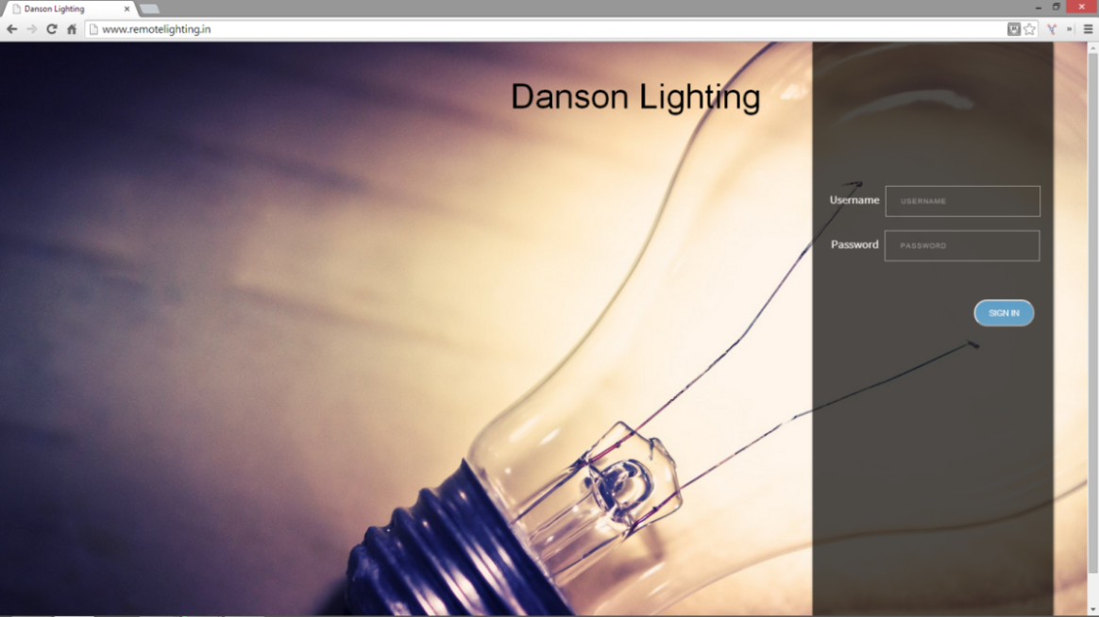

Fig. 9.1: Login Page

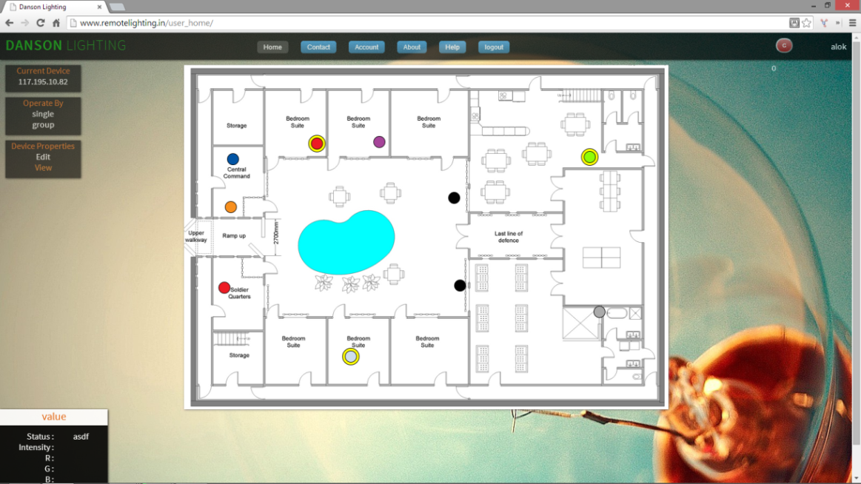

Fig 9.2: user home page

The circles represent the LEDs of the particular user after hovering over a LED the user can see the current status of that LED.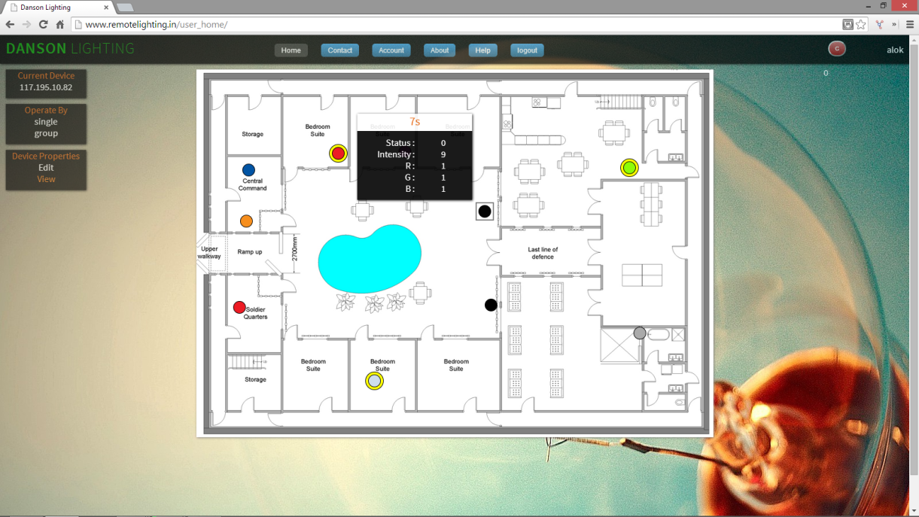

Fig 9.3: Current status of a LED.

User can change the status of a LED by clicking on that LED, a box appears with options that can be performed on the LED.

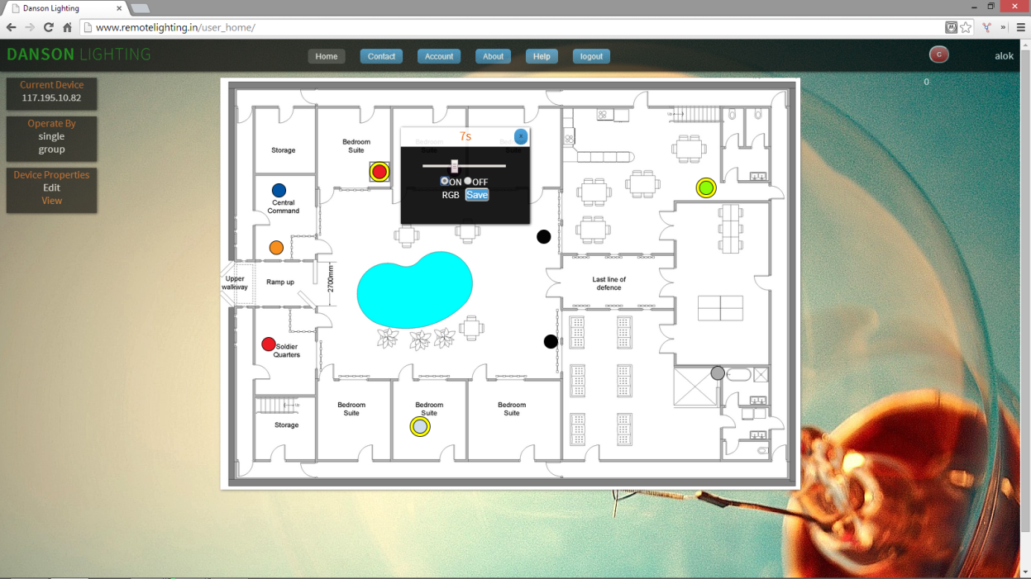

Fig 9.4: Operations that can be performed on LED

After changing the status of the LED the circle around the LED appears or disappears according to the operation.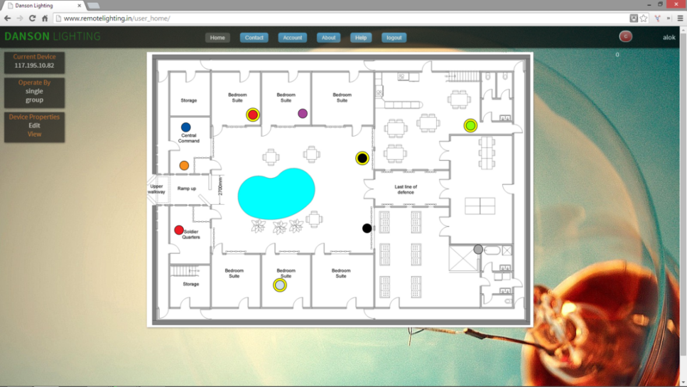

Fig 9.5: LED after changing its status

Some LEDs have the property to change colour, for such LED the system provides the RGB bar, from which user can select the combination as per user’s choice.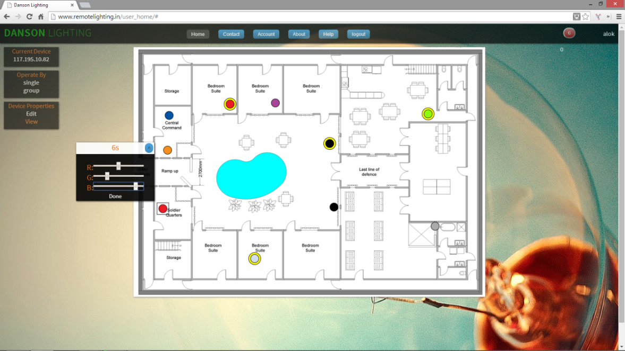

Fig 9.6: RGB option for a LED

The user can add new LED from the edit page, various options such as add, delete, changing LED representation colour is provided on this page.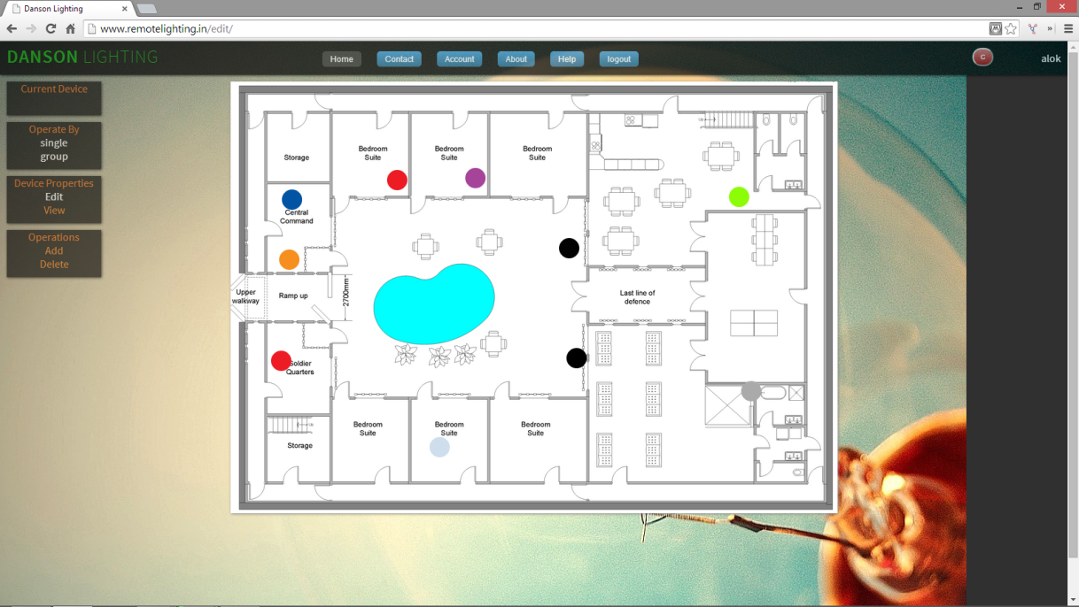

Fig 9.7: Edit page

After clicking on the add button, the system creates a new LED on the canvas at a fixed position, this can be moved named and user can choose the property of this LED.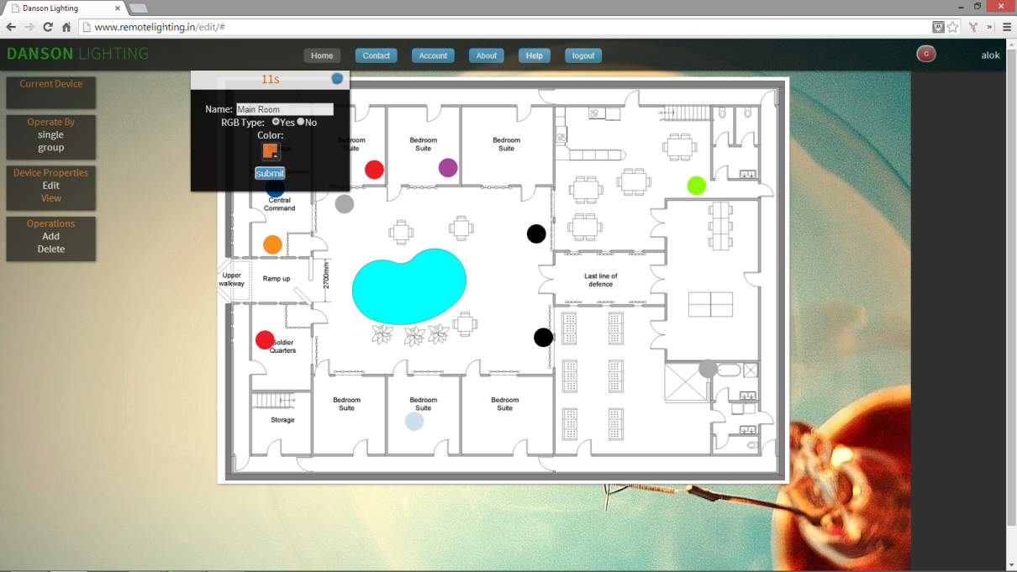

Fig 9.8: New LED after clicking on add button

The user selects the LED type while adding a new LED, from which on/off and intensity is default, the user has to select whether it can change colour no not.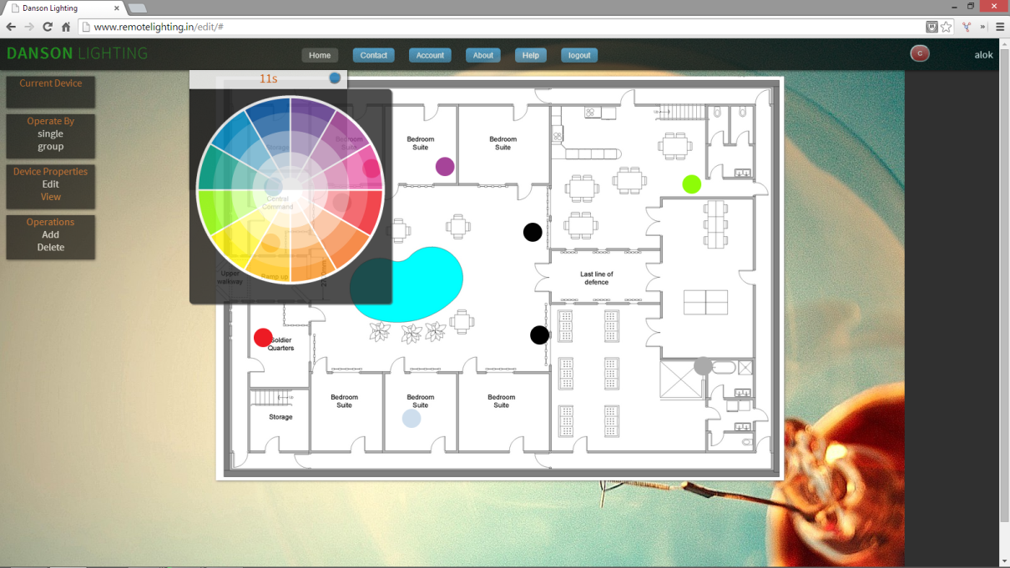

Fig 9.9: Colour palate for LED representation

User changes the position of the LED by using normal drag and drop technique with help of the mouse pointer and click on submit button to finalize the position.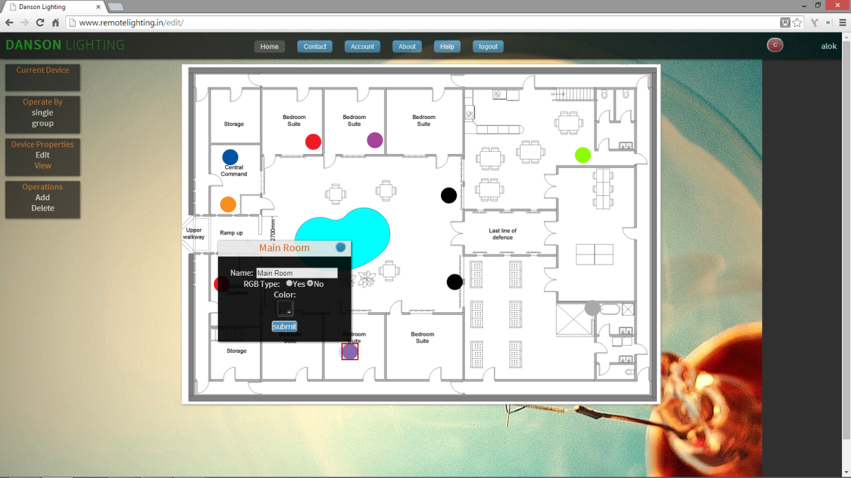

Fig 9.10: The new position of the LED after drag and drop operation

**10. DEPLOYMENT AND MAINTENANCE**

**10.1 INSTALLATION AND UNINSTALLATION**

The installation is divided into two parts, 1. Software. 2. Hardware.

1. Software:
   * 1. The application is completely web based application. The basic necessity of the system for the user to use is good internet connection and latest version of any internet browser.
     2. Recommended browser: Mozilla Firefox.
     3. And the system doesn’t require any installation on the software side apart from the internet browser.
2. Hardware:
   * 1. The hardware part requires installation. The installation will be done by the professionals from the company.
     2. The hardware used in the system are:
        1. Arduino Microcontroller and Ethernet shield.
        2. ZigBee Modules.
        3. Ethernet wire with 24/7 internet connection.
        4. LEDs and wiring.
     3. The entire system on the client side will be done by the professional given by the company; the user will be given basic guidelines of usage. The maintenance task will be taken up by the company.
     4. To uninstall the system the user will again have to contact the company and the company will uninstall the entire system.

**10.2 USER HELP**

The web application is very user friendly. The user will just have to logon to the website and the entire system will be accessible for the particular user. The navigation is also user friendly, so the user can easily browse through the web pages. A help page is also provided for the user on the website where all functionalities are described in steps. The hardware setup will be also elaborated to the user and a manual will be given for basic troubleshooting if any problem occurs at the client side.

**11. CONCLUSION AND FUTURE SCOPE**

ZigBee technology is a new wireless protocol that widely used in various areas for its excellent performance in reliability, power consumption, flexibility and cost. This paper introduced how to use ZigBee technology to realize wireless control in building lighting. The lamp node will turn to sleep mode when it is in off mode. Experiments proved that this system is low power consumption, low complexity and high reliable. It also meets the need of developing of data acquiring and control system in industrial automation. With the consequent develop of a series of products based on ZigBee protocol, more attention and development will be dedicated to the fields of application design and realization ,interoperability test and market promotion. We believe that more and more build-in ZigBee function equipments will be widely used in military and civil area in the near future.

The system developed successfully implements the remote lighting technology. It allows the user to control the lights remotely from any geographical location through the internet by using just an internet browser which is present on the PC, laptop, or even on mobile phones.

The system is very cost effective saving user’s both time and money and the effort to physically be present at the location and change the switch for every light.

**12. REFERENCES**

[1] REN Feng-Yuan, HUANG Hai-Ning, LIN Chuang, “Wireless Sensor Networks” Journal of Software, Vol.14, Jul.2003. pp.1282-1291.

[2] Shigeru Fukunaga Et Al. Development of Ubiquitous Sensor Network, Oki Technical Review, Vol.7 1, No.3, pp. 24-29, October 2004

[3] “ZigBee Based Wireless Sensor Networks and Its Applications in Industrial” 2009 IEEE International Conference on Information Acquisition 24-27 May. 2009 Page(s): 1979-1983

[4] Fabio Leccese “Remote-Control System of High Efficiency and Intelligent Street Lighting Using a ZigBee Network of Devices and Sensors” in Proc IEEE Transactions On Power Delivery, Vol. 28, No. 1, January 2013. Pp. 21-28

[5] Adeel A. Siddiqui “Zigbee Based Energy Efficient Outdoor Lighting Control System” ISBN 978-89-5519-163-9, Feb. 19~22, 2012 ICACT2012

[6] Maoheng Sun, “An Implementation of Remote Lighting Control System Based on Zigbee Technology and Soc Solution”, Automation and Logistics, 2007 IEEE International Conference on 18-21 Aug. 2007 Page(s): 629-632

[7] ZigBee Alliance <http://www.zigbee.org>

[8] Z-Stack User's Guide-Texas Instruments, Inc. 2005,

<http://www.ti.com/lsds/ti/wireless_connectivity/zigbee/overview.page>

[9] <http://www.python.org>

[10] <http://www.djangoproject.com>

[11] <http://www.djangobook.com>

[12] <http://www.stackoverflow.com>

[13] <http://en.wikipedia.org>

[14] <http://www.remotelighting.in>

[15] <http://www.arduino.cc>

[16] <http://www.remotelighting.in>

[17] [http://www.w3schools.com](http://www.remotelighting.in)